Week in Review - January 18-24
Alex Shvartsman

EVENT HORIZONS INVITATIONAL
The 16 player Invitational took place at the Bower Game Center in Houston over the weekend. Players battled it out in five unique formats. In the end, Skye Thomsen swept Rick Burton in a Continuous Draft finals. Thomsen recently moved to Texas to attend college. He previously won a New Jersey State Champion title and finished in the top 64 of the most recent PT Chicago.
Complete coverage of this event by yours truly and Mason Peatross will available on The Sideboard later today.

COMING UP: GRAND PRIX HIROSHIMA

The last Grand Prix of this sub-season, this tournament will offer one more chance for players to improve or solidify their PT point standings, before another important run at PTLA. GP Hiroshima will likely be a very large tournament (most Japanese events are) with many international players attending (I will be there, as will Ryan Fuller. Several will likely attend).
A number of Japanese players have a pair of Grand Prix wins under their belt by now. This weekend will be their chance to challenge Kai Budde's crown by matching his triple GP win record. The format for this tournament will be Invasion sealed deck, followed by day 2 booster draft.

COMING UP: PLANESHIFT PRERELEASE

This weekend will give players a chance to take a first look at the new set, with a series of sealed deck and draft tournaments. The Sideboard has been featuring Planeshift card previews. Today's card is Hull Breach, reviewed by Brian Kibler and Aaron Forsythe.

DEMISE OF THE DOJO
Popular independent strategy web site The Dojo announced this week that it will be closing its doors for good.

Dojo rose to notoriety in 1997, when computer expert Frank Kusumoto created a web site with an ambition to highlight and archive the best Magic related posts from the Usenet newsgroups. Players were quick to support this undertaking. Soon, tournament reports and articles were sent directly to Mr. Kusumoto, as well as onto the newsgroups. Soon after that, many of the players would only send their writings to The Dojo.
Strategy web sites have existed before - most popular being The Vault magazine - but none rose to the same prominence. With increased traffic, submissions, and overall importance, handling the web site became more and more difficult for Kusumoto, who had a day job to consider.
Eventually, Kusumoto transferred control of the site to Robert Hahn. Author of the famous Schools of Magic, Hahn was one of Kusumoto's inspirations for starting The Dojo in the first place. Now, Hahn finished college and, after a short stint as a Duelist editor, was looking for a new job. He believed he could make The Dojo into a profitable business.
Thus, Psylum, Inc. was formed. Over the next two years The Dojo has undergone a number of changes, and a number of editors - including Mike Flores, Adrian Sullivan, and Charles Hwa. Psylum opened a number of other web sites, such as PokeGym and PsyComic. Psylum's business plan was to market the "community web site" software, but like so many other Dot Coms, it never became profitable.
Furthermore, The Dojo rapidly lost ground to aggressive new strategy web sites which could - and did - generate revenue for their operators through card sales. Mindripper, Star City and a host of others was able to better compensate writers and quickly overcame the Dojo in quality and quantity of content.
In 2000, Psylum sold its web sites to USA Networks. Chris Senhouse was hired as The Dojo editor, with Al Tran remaining its webmaster. The Dojo seemed to begin a re-emergence as a force among the strategy web sites for a short period of time, but USA Networks, for the reasons best known to them, chose to pull the plug.
The Dojo is not so important as a source of strategy right now - plenty of other sites, including this one, offer that. It is the idea, being the very first of the breed, makes Dojo the site that no one wants to ever see go. It will certainly be missed.

MAGIC TRIVIA
Last week's question was to try and name all possible cards that could allow you to build a deck of 60 of them (thus, no basic lands) and still be able to deal twenty damage to an opponent. There are twelve cards that we know of, capable of doing that.
Mishra's Factory and other creature-lands are relatively obvious. Besides the Factory, there are Stalking Stones, Faerie Conclave, Forbidden Watchtower, Spawning Pool, Ghitu Encampment and Treetop Village. Non-land answers include Nether Shadow, Nether Spirit, Elvish Spirit Guide, Vine Dryad and Cave-In. Had the question been worded a little differently, and the goal was to win the game rather than deal 20 damage to your opponent, Cave-In would not work as an answer - but Serra Avatar would, as you would eventually deck your opponent, regardless of his own deck size.
On to this week's trivia question:
What was the very first unique promotional card?
Please do not e-mail me with your answers. There is no prize, this is strictly for fun. Correct answer will be posted in the next week's column.

BEST OF THE NET

This week's best article was written by Nate Heiss. He takes a very interesting look at the future of Magic, and the ways in which it can be made accessible and interesting to more people. He argues that Magic needs to become more dramatic, follow the story lines and the personalities of the players more so than the cards, in its online and televition coverage. Heiss' article can be found here.

GOOD/BAD PLAY OF THE WEEK?
Thanks to Gert Coeckelbergh, who submitted the following:
"I have either a good or a bad play for you, depends how you look at it;
It was round 8 of the first day at GP Amsterdam, with Chris Benafel and Jan Doise facing each other;
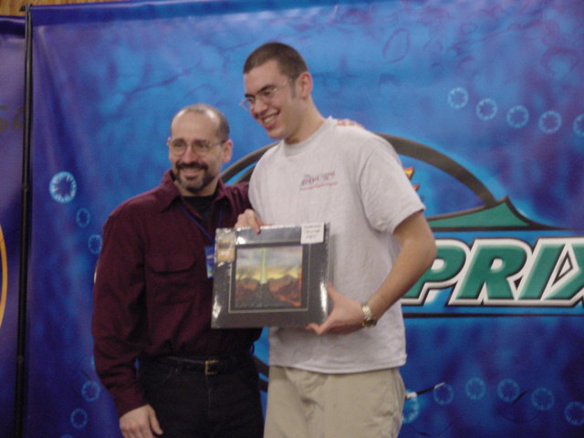
Both had perfect 7-0 records and were looking for that undefeated Day 1 finish. Jan had a Wayfaring Giant in play, along with a Dream Thrush and another creature; Chris had three creatures in play of his own. From the beginning of the game, Jan suspected that Chris had an Explosive Growth in hand, so when Chris attacked with his three creatures, Jan had to block in such a way that he wouldn't die to a kicked Growth. He blocked Chris' Serpentine Kavu with his Giant.
Chris indeed had the Growth, and played it on the Kavu without kicker, even though he could pay the kicker cost. But Jan had one trick up his sleeve; He had Islands, Plains and Forests in play, but used his Dream Thrush to turn one of his lands into a Swamp, making the Giant big enough to survive. Next turn Jan was able to attack for the win with the Giant and end up 8-0!"
As always, please send good/bad plays and other news to ashv@concentric.net.

